Introduction of 520 DC gear motor

Product Introduction

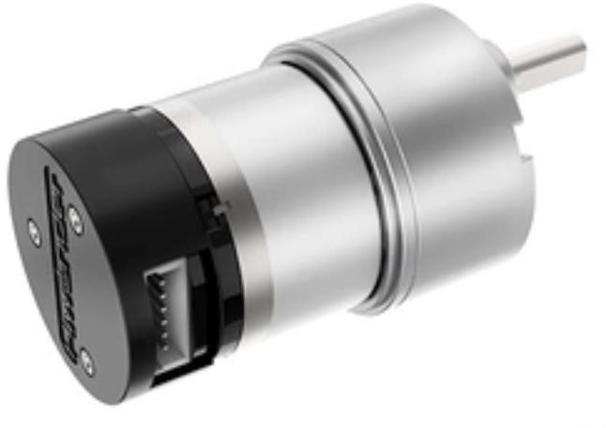520 Hall coding DC gear motor is a high torque, high load motor, 12V DC motor. Hall speed measuring code disk is a speed measuring module using Hall sensor encoder. It is equipped with strong magnetic code disk and outputs pulse signals through AB two-phase, which can detect the rotation direction and speed of the motor and is suitable for intelligent cars with high speed requirements. Such as McNamee wheel car, balance car, navigation and positioning car.

Parameter Description

  - Specifications

Parameters | JGB37-520R20-12 | JGB37-520R30-12 | JGB37-520R60-12 | JGB37-520R90-12
Reduction ratio | 1:20 | 1:30 | 1:60 | 1:90
No-load speed | 500rpm | 320rpm | 170rpm | 110rpm
Rated speed | 390rpm | 280rpm | 146rpm | 85rpm
Stall-rotor torque | 3.7kg*cm | 5.8kg*cm | 9.2kg*cm | 15kg*cm
Rated torque | 1kg*cm | 1.2kg*cm | 1.9kg*cm | 2.6kg*cm

Stall current | 3.9A | 3.2A | 3.2A | 3.2A
Rated current | 0.36A | 0.36A | 0.53A | 0.36A
Rated power | Approximately 9W | Approximately 9W | About 7W | About 83W
Rated voltage | 12V
Encoder Class  Type | AB two-phase encoder
Motor type | permanent magnet brush
Output shaft | Diameter 6mmD type eccentric shaft
Encoder electric  Pressure | 3.3~5V
Number of magnetic loops | 11 line.
Interface Type | PH2.0-6PIN
Function | With pull-up shaping, the microcontroller can directly read the signal pulse
Single motor weight  Quantity | 152+1G

  - 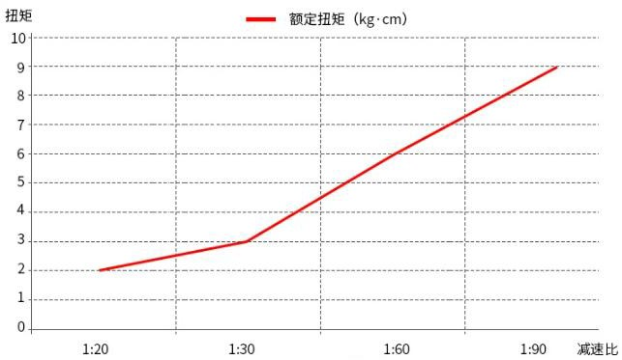Under the condition that the internal motor of the geared motor remains unchanged, the relationship between the gear reduction ratio in the reduction box and the speed and torque: the larger the reduction ratio, the greater the torque, and the smaller the speed.

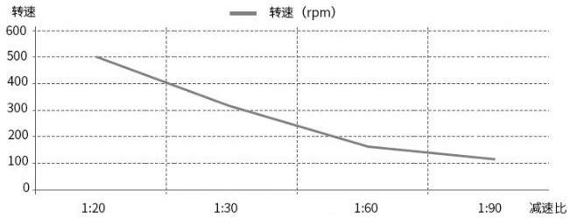

  - Motor model description:
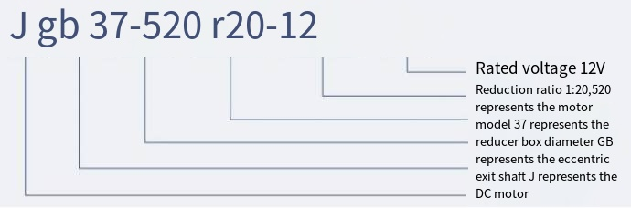

  - Pin Description

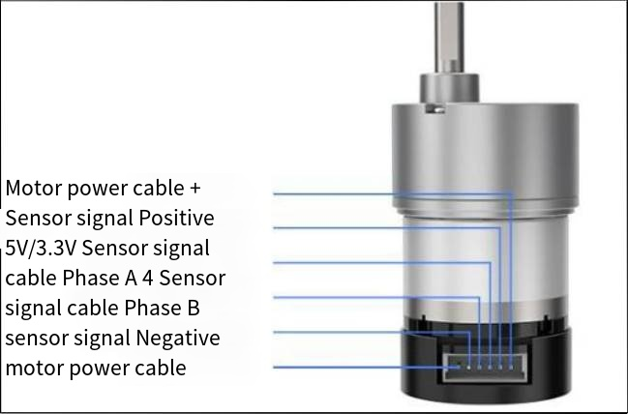

Label | Description
GND | Hall power supply negative pole
C1 | Hall C1 output signal, square wave
C2 | Hall C2 output signal, square wave
VCC | Hall power supply positive pole
M1 | Positive pole of motor power supply
M2 | Negative pole of motor power supply

Remarks:

1. The voltage between the VCC-GND is determined according to the power supply voltage of the single-chip microcomputer used, and 3.3V or 5V is generally used.

2. The frequency of the output square wave of C1 and C2 is related to the motor speed and the number of poles of the magnetic sheet used.

3. The voltage between M1 and M2 depends on the motor voltage used.

